Objectives:

* Creating Dictionaries and Sets & Object Serialization

Please submit screenshots of output this document for grading when completed.

**GitHub URL:** [CMPR-114/Module 8_Strings, Sets and Dictionaries/M7 Class Exercise 7 Sets Dictionaries at master · ManVien/CMPR-114 (github.com)](https://github.com/ManVien/CMPR-114/tree/master/Module%208_Strings%2C%20Sets%20and%20Dictionaries/M7%20Class%20Exercise%207%20Sets%20Dictionaries)

**There are 4 Challenge Exercises, each worth 25%**

Tuples are **used to store multiple items in a single variable**.

**Project #1** (creating dictionaries). uses a dictionary to simulate a standard deck of

poker cards

**Program’s code and output:**

**Project #2** Keeps your friends’ names and birthdays in a

Dictionary

**Program’s output:**

**Project #3** (creating list box using Tkinter)

**Challenge Exercise #1: Basketball**

**Program’s code and output:**

**Project #4** (Serialization)

**Program’s code and output:**

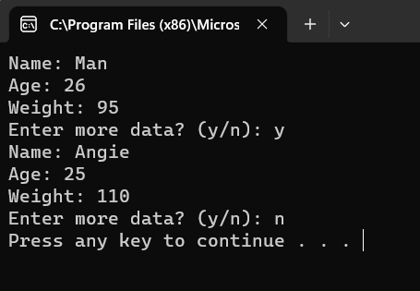

**Program’s code and output:**

**Challenge Exercise #2:** continuing with project #3, print the food items.

**#2 print screen the running application with code below here.**

**Program’s code and output:**

**Project #5:** *Replacing* an old item in a list with a new item

**Program’s code and output:**

**Project #6:** This program will demonstrate how to insert and remove items in a list, and total and average number of items in a list.

**Program’s code and output:**

**Challenge Exercise #4:** continuing with project #6, the total function, output the numbers list to a text file.

**#4 print screen the running application with code below here.**

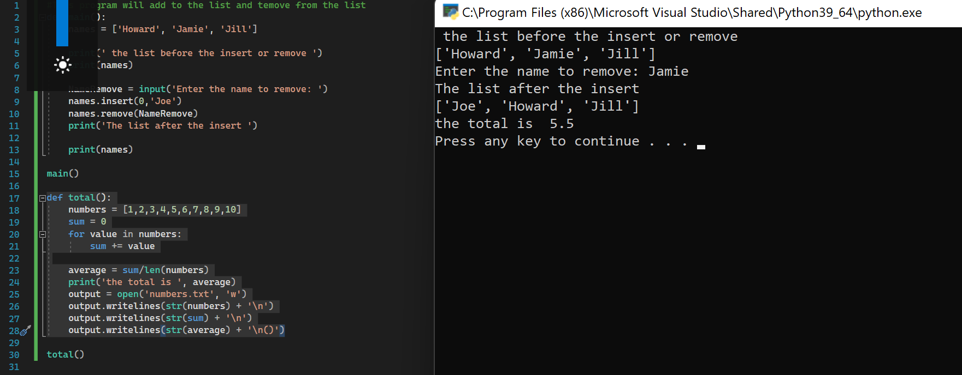

**Program’s code and output:**

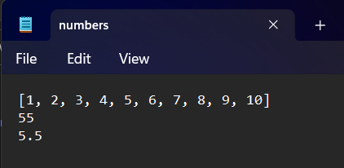

**Challenge Exercise #4:** TOTAL SALES APP: Design a program that asks the user to enter a store’s sales for each day of the week. The amount should be stored in a list. Use loop to calculate the total sales for the week and display the result. Plus output the results into a text file as well as the console.

**#4 print screen the running application with code below here.**

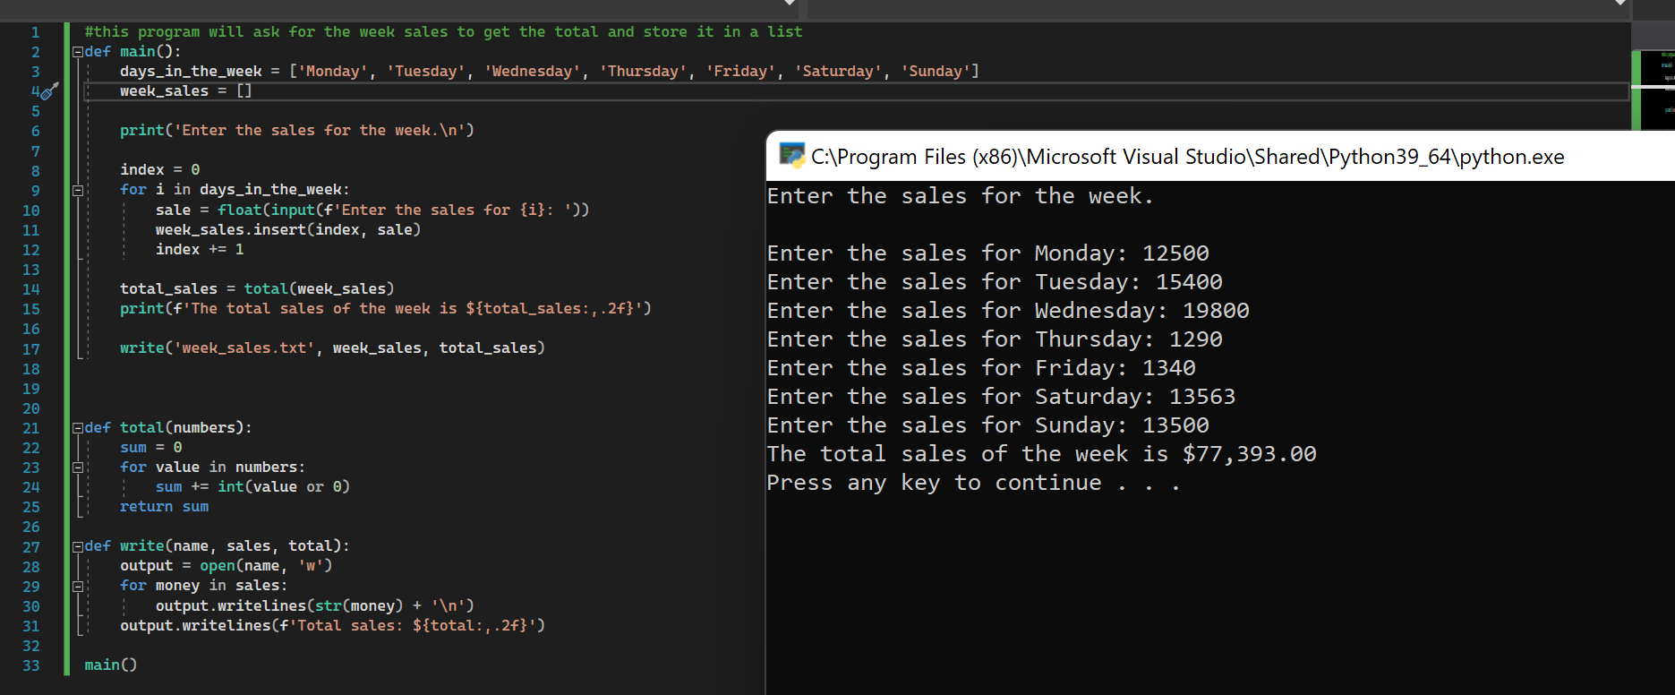

**Program’s code and output:**

**Challenge Exercise #5:** RAINFALL APP: Design a program that let’s the user to enter the total rainfall for each of the 12 months into a list. The program should calculate and display the total rainfall for the year, the average monthly rainfall, the months with the highest and lowest amounts of rainfall. Plus output the results into a text file as well as the console.

**#5 print screen the running application with code below here.**

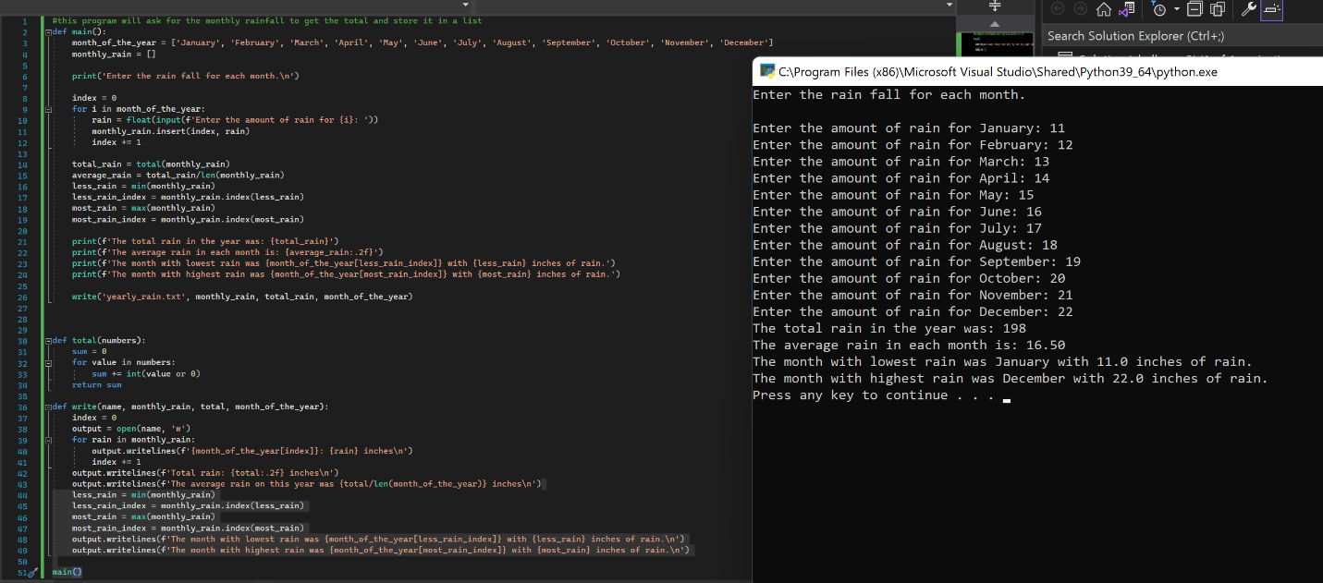

**Program’s code and output:**

**Submit this document to Module 7 Class Exercise #6**